**Advance Software Engineering**

Assignment – 3

WCF Restful Service & Mash Up.

Surendra Koripella

16143350

Installation Results of IIS Server

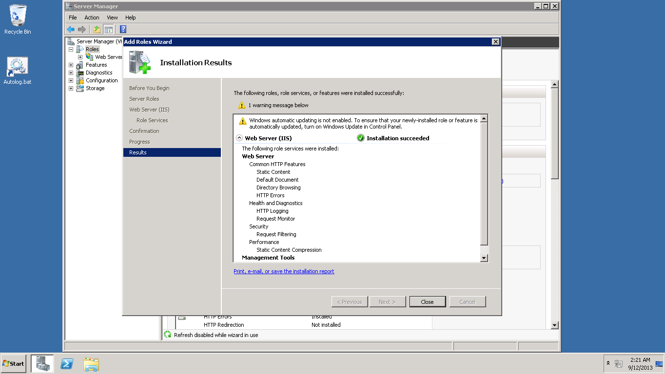

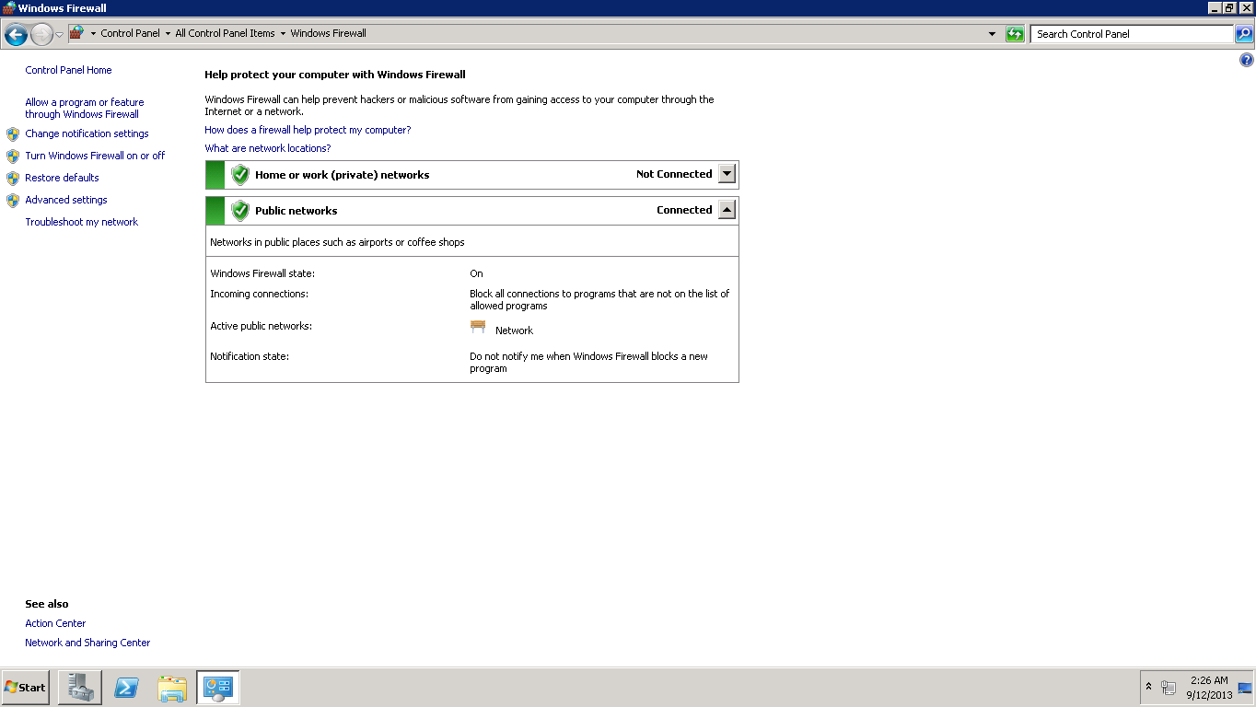

Results of Setting up firewall correctly

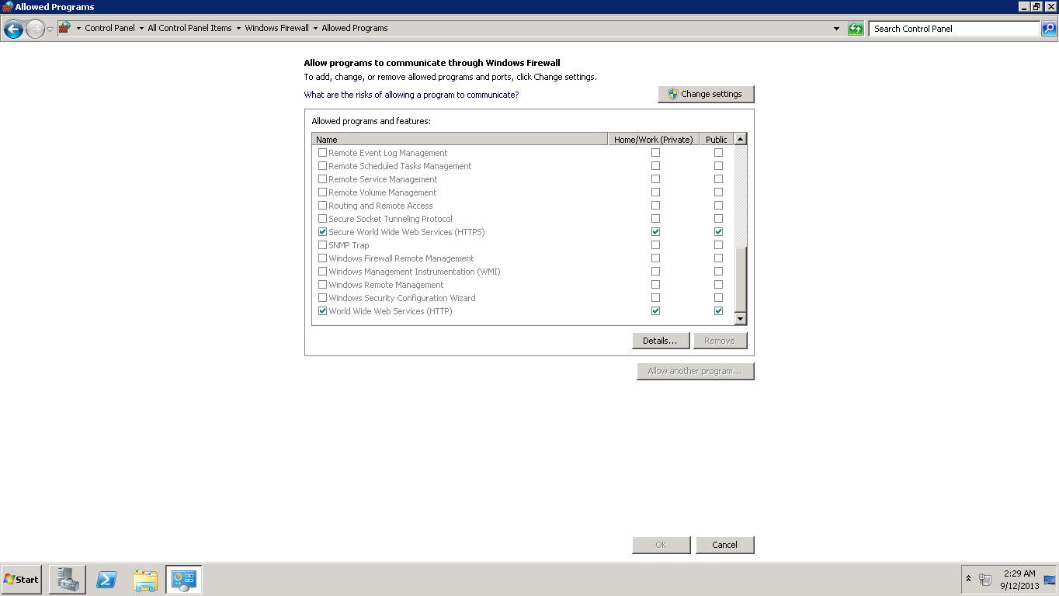

ApplicationHost in Notepad.

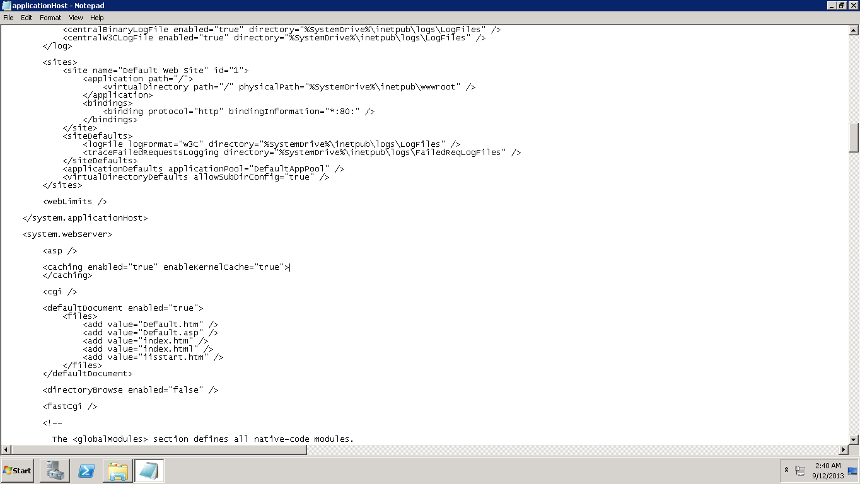

Add 3.5.1 framework Feature

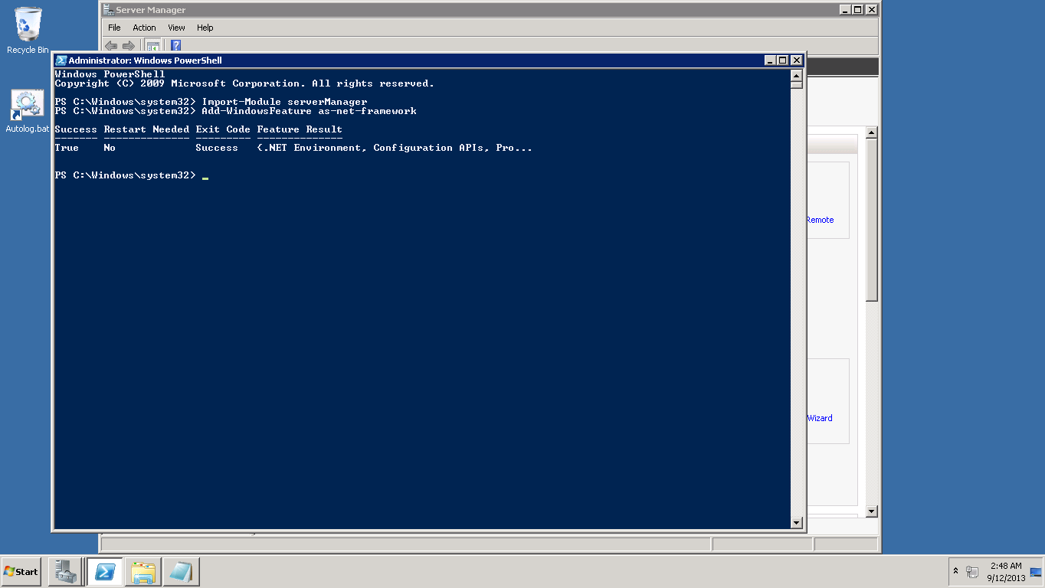

Deploying my Web Service

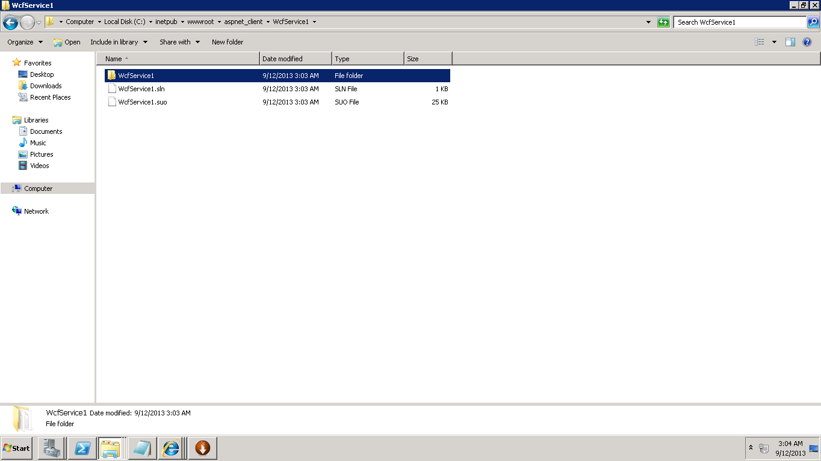

Conversion of web service to application process

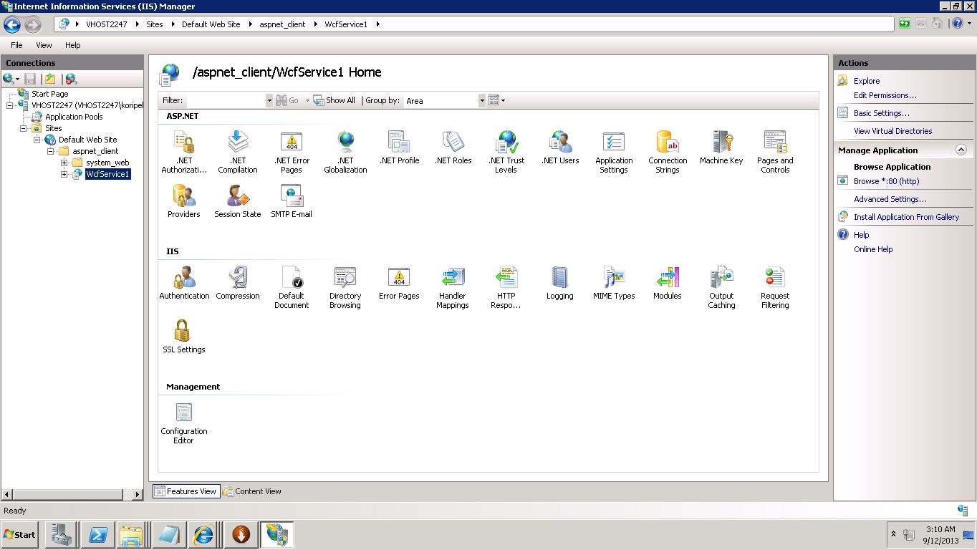

Result of deploying IIS Server

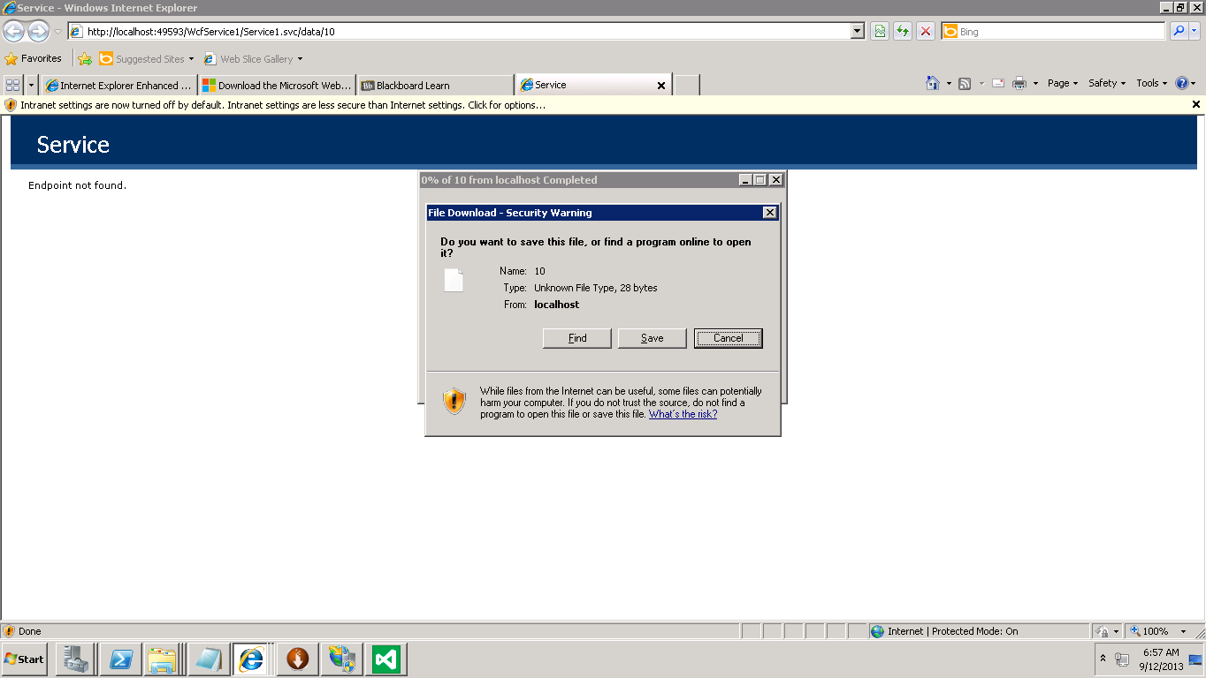

Output of deploying IIS Server.

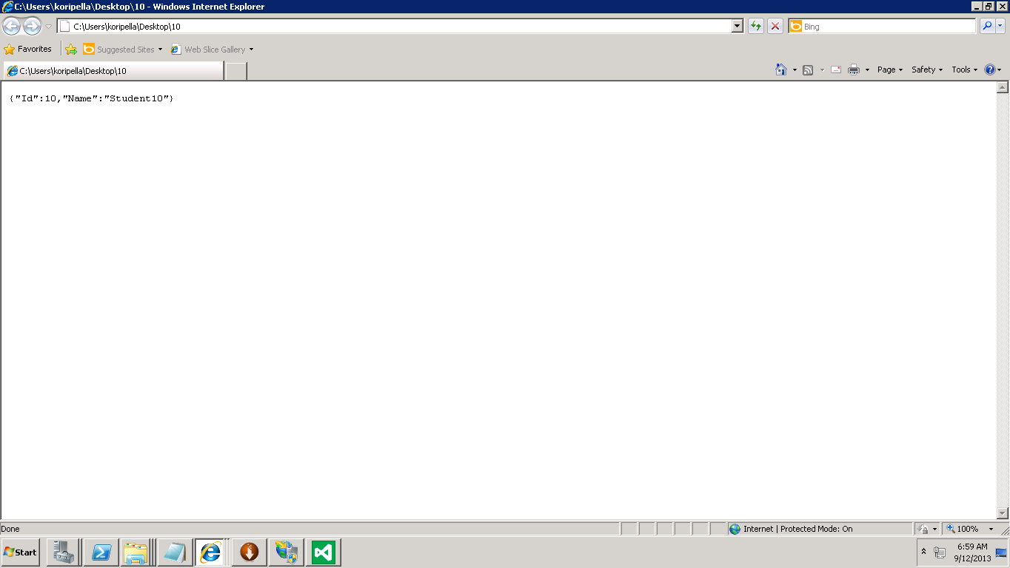

**Mash Up**

Html Code:

<html xmlns="http://www.w3.org/1999/xhtml"><head>

<meta name="google-site-verification" content="sj_GBtmSdT0NhKxkoIabhRg_eXaWhqTqZGOlQ6DQAPo">

<title>Kansas City Restaurant Locator | Chowhound Reviews</title>

<meta http-equiv="content-type" content="text/html; charset=utf-8">

<link href="css/restocan_v2.css" type="text/css" rel="Stylesheet">

<link href="css/jquery.tooltip.css" type="text/css" rel="Stylesheet">

<link rel="stylesheet" type="text/css" href="http://yui.yahooapis.com/2.4.1/build/tabview/assets/skins/sam/tabview.css">

<script type="text/javascript" src="http://yui.yahooapis.com/2.4.1/build/yahoo-dom-event/yahoo-dom-event.js"></script>

<script type="text/javascript" src="http://yui.yahooapis.com/2.4.1/build/element/element-beta-min.js"></script>

<script type="text/javascript" src="http://yui.yahooapis.com/2.4.1/build/tabview/tabview-min.js"></script>

<script type="text/javascript" src="js2/jquery-1.3.2.min.js"></script>

<script type="text/javascript" src="js2/dimensions.js"></script>

<script type="text/javascript" src="js2/jquery.tooltip.min.js"></script>

<meta name="keywords" content="reataurant guide, thai, italian,french,steakhouse, indian, chinese">

<meta name="description" content="An user-friendly locator of restaurants all across Kansas City.">

<link rel="SHORTCUT ICON" href="http://restocan.com/favicon.ico">

<script type="text/javascript">

$(function(){

$('.location_desc').hide();

var tooltipContent = function() {return this.nextSibling.nextSibling.innerHTML;}

$('.location_link').tooltip({showURL: false, bodyHandler: tooltipContent});

});

function initTabView() {

var tabs = new YAHOO.widget.TabView("tab_view");

}

</script>

<style type="text/css"></style>

<body onload="initTabView()" class="yui-skin-sam">

<center>

<!--<img src="http://restocan.com/icones/Kansas City_restaurants.png" alt="Restaurant locator" />-->

</center>

<h1>Kansas City Restaurant Locator</h1>

<div class="content">

<div id="tab_view" class="yui-navset yui-navset-top">

<ul class="yui-nav">

<li class="selected" title="active"><a href="#restaurant_KC"><em>Kansas City Restaurants</em></a></li></ul>

<div class="yui-content">

<div id="restaurant_KC" style="display: block;">

<p><strong>Please click below to find your desired restaurant in KC.</strong></p>

<div align="center"><h2>Kansas City Restaurants</h2>

<div data-role="page" id="home">

<header data-role="header">

<h1>KC Restaurant Finder</h1>

<a href="#"></a>

</header>

<!-- Page 2-->

<div data-role="page" id="">

<header data-role="header">

<h1></h1>

<!-- Place this tag where you want the +1 button to render. -->

<div class="g-plusone" data-annotation="inline" data-width="300"></div>

<!-- Place this tag after the last +1 button tag. -->

<script type="text/javascript">

(function() {

var po = document.createElement('script'); po.type = 'text/javascript'; po.async = true;

po.src = 'https://apis.google.com/js/plusone.js';

var s = document.getElementsByTagName('script')[0]; s.parentNode.insertBefore(po, s);

})();

</script>

<a href="http://www.yelp.com/kansas-city-mo-us" data-icon="Home">Click Here</a>

<a href="https://twitter.com/share" class="twitter-share-button">Tweet</a>

<script>!function(d,s,id){var js,fjs=d.getElementsByTagName(s)[0],p=/^http:/.test(d.location)?'http':'https';if(!d.getElementById(id)){js=d.createElement(s);js.id=id;js.src=p+'://platform.twitter.com/widgets.js';fjs.parentNode.insertBefore(js,fjs);}}(document, 'script', 'twitter-wjs');</script>

</header>

<body onload="initialize()">

<div id="map_canvas" style="height: 40000px; width: 40000px"></div>

</body>

</div>

<!--Page 2-->

<a href="http://www.yelp.com/kansas-city-mo-us"> Home </a>

</div><center><table width="80%" cellspacing="0"><tbody><tr><td class="section_col"><div class="location_entry loc_a"><a

</div>

<div id="restaurant_KC" style="display: none;">

<p><strongPlease select a restaurant locator from the table below.</strong></p>

<div align="center"><h2>K.C. Restaurants</h2></div><center><table width="80%" cellspacing="0"><tbody><tr><td class="section_col"><div class="location_entry loc_a"><a.).</span></div><br></td></tr></tbody></table></center>

</div>

</div>

</div>

<br>

<div class="footer">© 2007-2013 Kansas City Restaurant Locator </div>

<!-- Start of StatCounter Code -->

<script type="text/javascript" language="javascript">

var sc_project=2690384;

var sc_invisible=1;

var sc_partition=26;

var sc_security="4dc17a2b";

</script>

<script type="text/javascript" language="javascript" src="http://www.statcounter.com/counter/counter.js"></script><noscript>&lt;a href="http://www.statcounter.com/" target="_blank"&gt;&lt;img src="http://c27.statcounter.com/counter.php?sc_project=2690384&amp;java=0&amp;security=4dc17a2b&amp;invisible=1" alt="blog stats" border="0"&gt;&lt;/a&gt; </noscript>

<!-- End of StatCounter Code -->

<!--Google analytics -->

<script src="http://www.google-analytics.com/urchin.js" type="text/javascript">

</script>

<script type="text/javascript">

_uacct = "UA-887442-3";

urchinTracker();

</script>

<!--End Google analytics -->

<!-- End Content -->

</div>

<div id="tooltip" style="display: none; left: 854px; right: auto; top: 267px;" class=""><h3 style="display: none;"></h3><div class="body">Restaurants in Prince George (2).</div><div class="url" style="display: none;"></div></div></body></html>

Screenshot of my mashup showing restaurant locator.

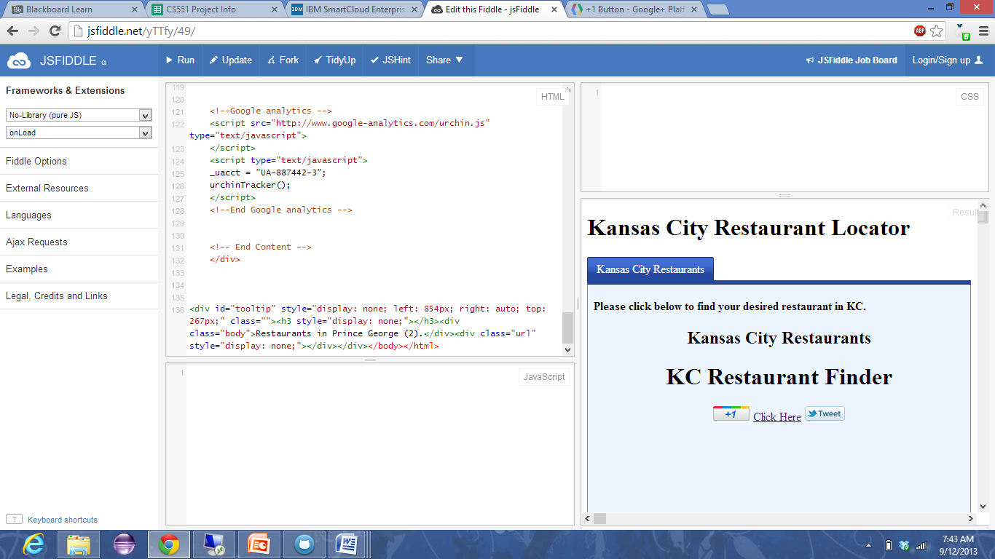

Screenshot showing mashup using yelp

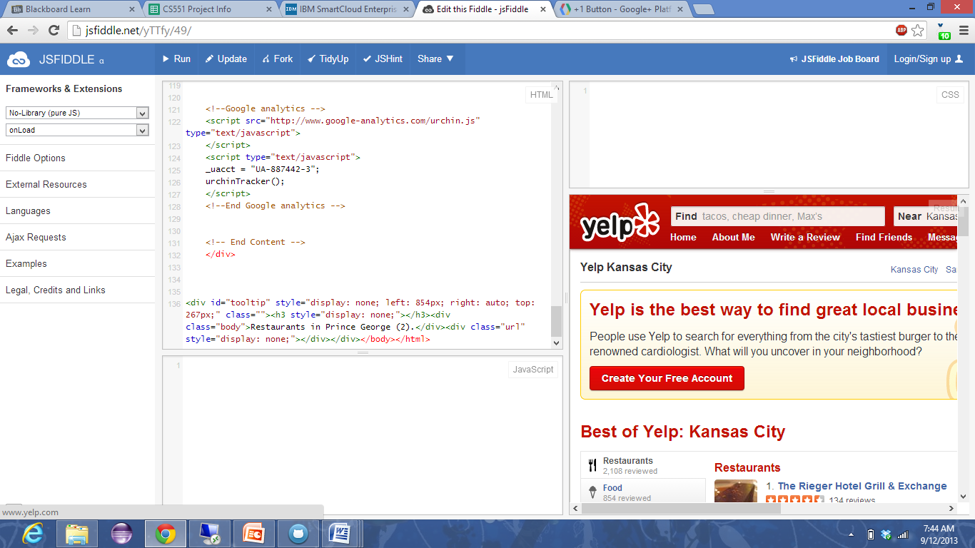

Screenshot showing map of “**Taco bell**” restaurants in and around Kansas City.

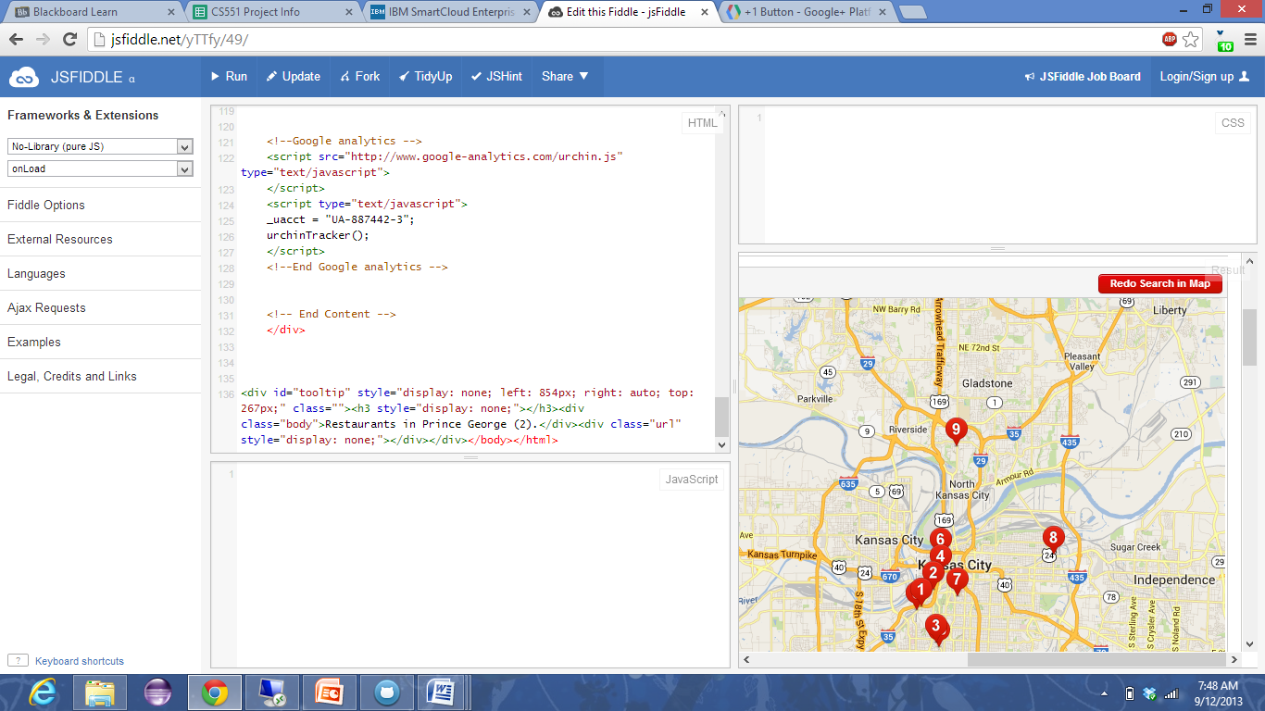

**Report**

In my mash up exercise, I have designed a mash up of Kansas City Restaurant Locator which is used to find and locate the restaurants inputed in to the search box using the yelp and maps services. Here when a user clicks on Click Here button he will be directed to yelp page where he can search the desired restaurants he/she wants and can also get the maps and address of the desired restaurants.

Also I have added the **twitter** button and **google+** button so that they can share their updates and be in touch with their friends, so here I added a touch of social networking which is important for everyone.